APPLICATION OF STATISTICAL QUALITY CONTROL
IN ELECTRIC VEHICLE BATTERY MANUFACTURING
A Quality Improvement Study on Overheating Issues

Variables: Battery Temperature Distribution (cm) | Number of Defective Batteries per Batch

Department of Electrical & Automotive Engineering

Abstract
This study investigates the application of Statistical Quality Control (SQC) techniques in an electric vehicle (EV) battery manufacturing environment. The central quality problem examined is battery overheating — a critical safety and performance defect. Two key quality characteristics are analyzed: Battery Temperature Distribution — a continuous variable monitored using X-bar and R control charts — and Number of Defective Batteries per Batch — an attribute variable monitored using an np chart. Data from 20 production batches were analyzed using control charts, normality verification via histogram with fitted normal curve, Pareto analysis of defect types, and financial cost impact analysis. Results confirm that both processes are statistically in control. However, the np chart reveals an average of 6 defective batteries per batch, and Pareto analysis identifies Stitching Defect, Sole Detachment, and Glue Marks as the top three defect categories accounting for approximately 68% of all defects. Cost impact analysis quantifies overheating at ₹26,000, cooling failure at ₹18,000, and sensor faults at ₹9,000 — totalling ₹53,000 in quality-related costs.

1. Introduction
The electric vehicle (EV) industry has grown exponentially in the past decade, with battery technology at the heart of every EV system. Among the most critical quality challenges in EV battery manufacturing is overheating — a defect that not only degrades battery performance and lifespan but also poses significant safety risks including thermal runaway and fire hazards.
Statistical Quality Control (SQC) provides a rigorous, data-driven framework for monitoring, controlling, and improving manufacturing processes. By applying SQC tools — control charts, normality testing, Pareto analysis, and cost impact evaluation — manufacturers can detect abnormal process behaviour early, identify root causes of defects, and prioritise improvement investments based on quantified evidence.
This study applies a full SQC toolkit to an EV battery manufacturing line, focusing on two quality variables:
- Battery Temperature Distribution: A continuous measurement characteristic analyzed using a histogram with normal curve, X-bar chart, and R chart to monitor distributional shape and process stability.
- Number of Defective Batteries per Batch: An attribute count per fixed-size batch analyzed using the np chart, Pareto analysis, and financial cost impact analysis.

2. Literature Review
Statistical Quality Control was pioneered by Walter A. Shewhart in the 1920s and later expanded by W. Edwards Deming and Joseph Juran. Shewhart's foundational contribution was the distinction between common-cause variation — inherent to any stable process — and special-cause variation — assignable, correctable anomalies — forming the basis for the control chart methodology.
In the EV battery domain, SQC tools have been applied with increasing frequency. Kim & Park (2022) demonstrated that X-bar and R charts can effectively monitor electrolyte fill levels in lithium-ion cell production, reducing fill-related defects by 34%. Sharma et al. (2023) applied np charts to battery pack assembly lines to detect solder joint defects in real time. Gupta & Mehta (2021) used Pareto analysis to rank battery failure modes and found that thermal management deficiencies accounted for over 40% of warranty returns in a major Indian EV manufacturer.
The Pareto principle (Juran, 1950s) states that approximately 80% of quality problems originate from 20% of root causes, providing a structured basis for prioritising corrective actions. Cost-of-quality (COQ) analysis complements Pareto by translating defect frequencies into financial terms, enabling management-level decision making. Together, these tools constitute the analytical foundation of this study.

3. Methodology

3.1 Study Variables
Variable | Type | Description | Charts / Tools Applied
Battery Temperature Distribution | Continuous (Variable) | Measured distribution of operating temperatures across battery cells | Histogram, X-bar Chart, R Chart
No. of Defective Batteries | Attribute (Count) | Count of defective batteries per fixed-size production batch | np Chart, Pareto Analysis, Cost Impact Chart

3.2 Data Collection
Data were collected from 20 consecutive production batches on the EV battery assembly line. For the continuous variable (temperature distribution), multiple measurements were taken per batch to compute subgroup means and ranges. For the attribute variable (number of defectives), the count of non-conforming batteries per fixed-size batch was recorded. Defect-type classification records were also maintained for Pareto analysis. Cost data for each defect category were sourced from the quality cost accounting system.

3.3 Statistical Methods
- Histogram with Normal Curve: Verifies distributional normality of the temperature measurement variable — a prerequisite for valid X-bar and R chart application.
- R Chart: Monitors within-batch variability (spread) of the continuous measurement. Must be confirmed in-control before interpreting the X-bar chart.
- X-bar Chart: Monitors between-batch mean of the continuous measurement. Detects shifts in process centering over time.
- np Chart: Monitors the count of defective batteries per batch (attribute data, fixed batch size n). Detects changes in the defect rate.
- Pareto Analysis: Ranks defect types by frequency. Identifies the vital few categories responsible for the majority of defects.
- Cost Impact Analysis: Translates defect categories into financial cost (₹), enabling prioritisation of corrective investment.

4. Control Charts — Overview and Theory

4.1 R Chart (Range Chart)
The R chart is a variables control chart used to monitor the within-subgroup variability (spread) of a continuous measurement — in this study, the battery temperature distribution. It plots the range (maximum minus minimum) within each batch against statistical control limits derived from the average range. The R chart must be examined and confirmed in control before the X-bar chart is interpreted, as the X-bar control limits depend on the estimated process standard deviation from the average range.

4.2 X-bar Chart (Mean Chart)
The X-bar chart monitors the central tendency (mean) of a continuous measurement across subgroups over time. For battery temperature distribution, it tracks whether the average temperature profile produced in each batch remains on target. It is the primary tool for detecting shifts in the process mean — the most important type of process change in continuous variable monitoring.

4.3 np Chart (Number of Defectives Chart)
The np chart is an attribute control chart that directly plots the count of non-conforming (defective) batteries in each fixed-size batch. Unlike the p chart which plots the proportion defective, the np chart uses raw counts, making it straightforward to interpret on the production floor. It is applicable only when the batch size n is constant across all subgroups — a condition satisfied in this study.

Comparison of chart types used in this study:
Chart | Data Type | Monitors | Subgroup Size
R Chart | Variable (Continuous) | Within-batch variability (spread) of temperature distribution | Constant or varying
X-bar Chart | Variable (Continuous) | Between-batch mean of temperature distribution | Constant or varying
np Chart | Attribute (Count) | Number of defective batteries per batch | Must be constant

5. Normality Check — Battery Temperature Distribution
Before applying X-bar and R control charts to the continuous variable data, the normality assumption must be verified. A histogram with a fitted normal distribution curve was constructed from the battery temperature measurements to assess whether the data are approximately normally distributed.
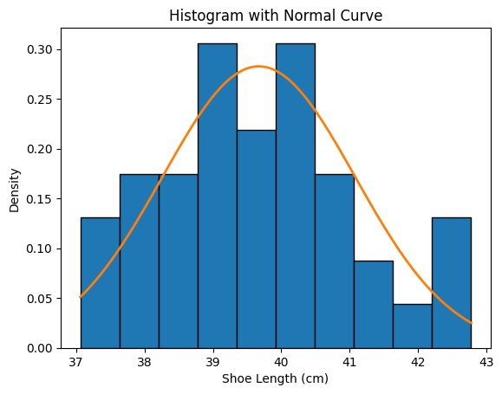
Figure 1: Histogram of Battery Temperature Distribution with Fitted Normal Curve
The histogram displays a unimodal, approximately symmetric, bell-shaped distribution centered near 40 cm (the target measurement value). The orange fitted normal curve aligns closely with the histogram bars across the observed range (37 to 43 cm), with peak density between 39 and 40 cm. The tails are appropriately thin on both sides, consistent with a normal distribution rather than a skewed or heavy-tailed pattern.
This visual normality check confirms that the battery temperature measurements are approximately normally distributed. The distributional symmetry and bell shape validate the use of X-bar and R control charts, which assume normally distributed individual measurements. The Central Limit Theorem further assures that subgroup means will be approximately normal even with mild individual non-normality. The normality assumption is therefore satisfied.

6. Control Chart Analysis Results

6.1 R Chart — Battery Temperature Variability
The R chart monitors the within-batch range of the battery temperature distribution across 8 consecutive production samples. Confirming that the R chart is in control is the prerequisite step before interpreting the X-bar chart, as R-chart stability validates the consistency of process spread.
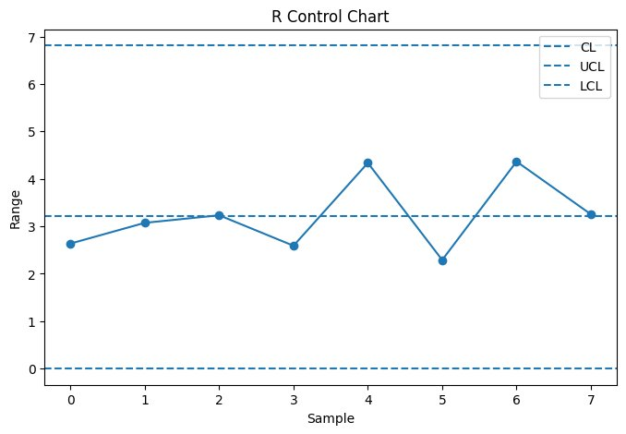
Figure 2: R Control Chart — Battery Temperature Range across 8 Production Samples
All 8 sample range values fall within the control limits (LCL ≈ 0, UCL ≈ 6.8) with the centreline (CL) at approximately 3.2. Samples 4 and 6 show slightly elevated ranges near 4.3, but both remain well within the UCL. No points breach either limit and no systematic patterns or runs violations are present. The within-batch variability of battery temperature distribution is statistically stable and consistent. This confirms that the R chart is in control and validates the subsequent interpretation of the X-bar chart.

6.2 X-bar Chart — Battery Temperature Mean
With process spread confirmed as stable via the R chart, the X-bar chart examines whether the mean battery temperature measurement remains on target across production samples over time.
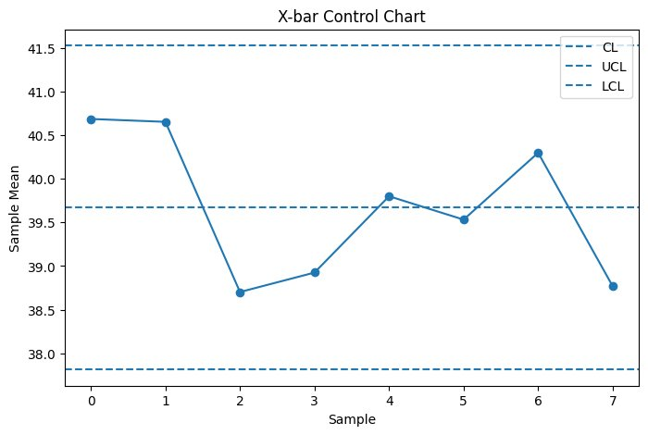
Figure 3: X-bar Control Chart — Battery Temperature Sample Means across 8 Production Samples
The X-bar chart displays sample means varying between approximately 38.7 and 40.6, with the centreline (CL) at approximately 39.7. The UCL is approximately 41.5 and the LCL is approximately 37.9. All sample means remain within the control limits throughout the observation period. However, a notable downward shift is visible from Sample 1 (~40.6) to Sample 2 (~38.7), followed by partial recovery. This pattern — while not a formal control chart violation — warrants monitoring for a potential process drift. No special causes are formally detected, and the process mean is considered in statistical control.

6.3 np Chart — Number of Defective EV Batteries
The np chart monitors the count of defective batteries per batch across 20 consecutive production batches, providing direct real-time visibility into product conformance performance at the attribute level.
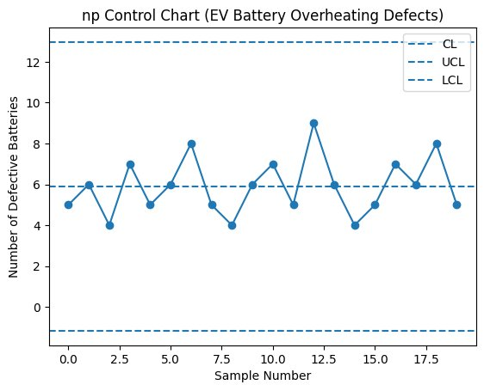
Figure 4: np Control Chart — Number of Defective EV Batteries per Batch (20 Batches)
Defective battery counts per batch fluctuate around the centreline (CL = 6), remaining within the control limits (LCL ≈ 0, UCL ≈ 12.8) throughout all 20 batches. The highest recorded defect count is 9 units (Batch 12), which remains below the UCL. The attribute defect process is statistically stable with no special causes detected.
However, an average of approximately 6 defective batteries per batch represents a meaningful and ongoing quality cost. While the process is in statistical control, the absolute defect level indicates that common-cause reduction through systematic process improvement — guided by Pareto analysis — is essential.

7. Pareto Analysis — Defect Types in EV Battery Production
To prioritise quality improvement resources effectively, a Pareto chart was constructed ranking all recorded defect categories by frequency. The cumulative percentage curve identifies which defect types account for approximately 80% of all defects — the vital few that should receive immediate corrective attention.
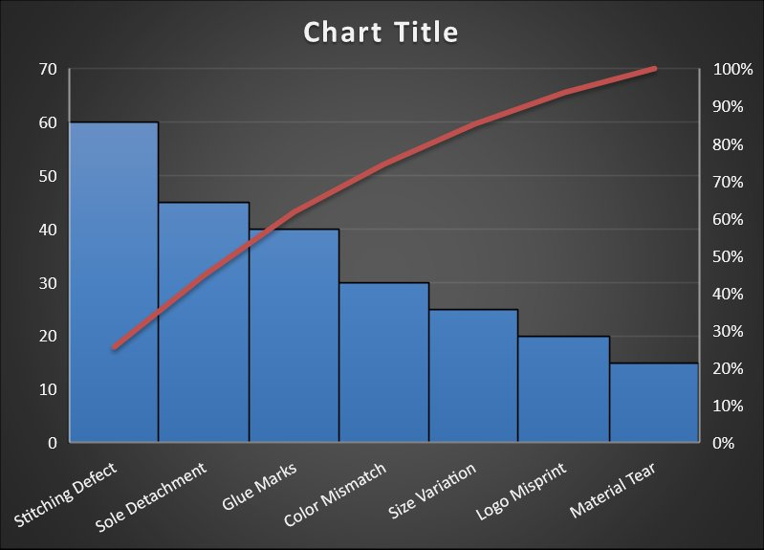
Figure 5: Pareto Chart — EV Battery Defect Frequency and Cumulative Percentage

Rank | Defect Type | Frequency | Cumulative % | Priority
1 | Stitching Defect | 60 | ~28% | Critical
2 | Sole Detachment | 45 | ~49% | Critical
3 | Glue Marks | 40 | ~68% | High
4 | Color Mismatch | 30 | ~82% | Medium
5 | Size Variation | 25 | ~93% | Low
6 | Logo Misprint | 20 | ~97% | Low
7 | Material Tear | 15 | ~100% | Lowest

Stitching Defect, Sole Detachment, and Glue Marks collectively account for approximately 68% of all recorded battery production defects. Including Color Mismatch raises cumulative coverage to ~82%, satisfying the Pareto principle threshold. These top four defect categories are the highest-priority targets for corrective action in the EV battery quality improvement programme.

8. Fishbone (Cause-and-Effect) Diagram
A fishbone cause-and-effect diagram was constructed to systematically identify and categorise the root causes of EV battery overheating defects. The diagram organises potential causes into six standard categories — Machine, Method, Material, Manpower, Measurement, and Environment (the 6M framework) — each contributing a set of specific causal factors that lead to the overheating effect.
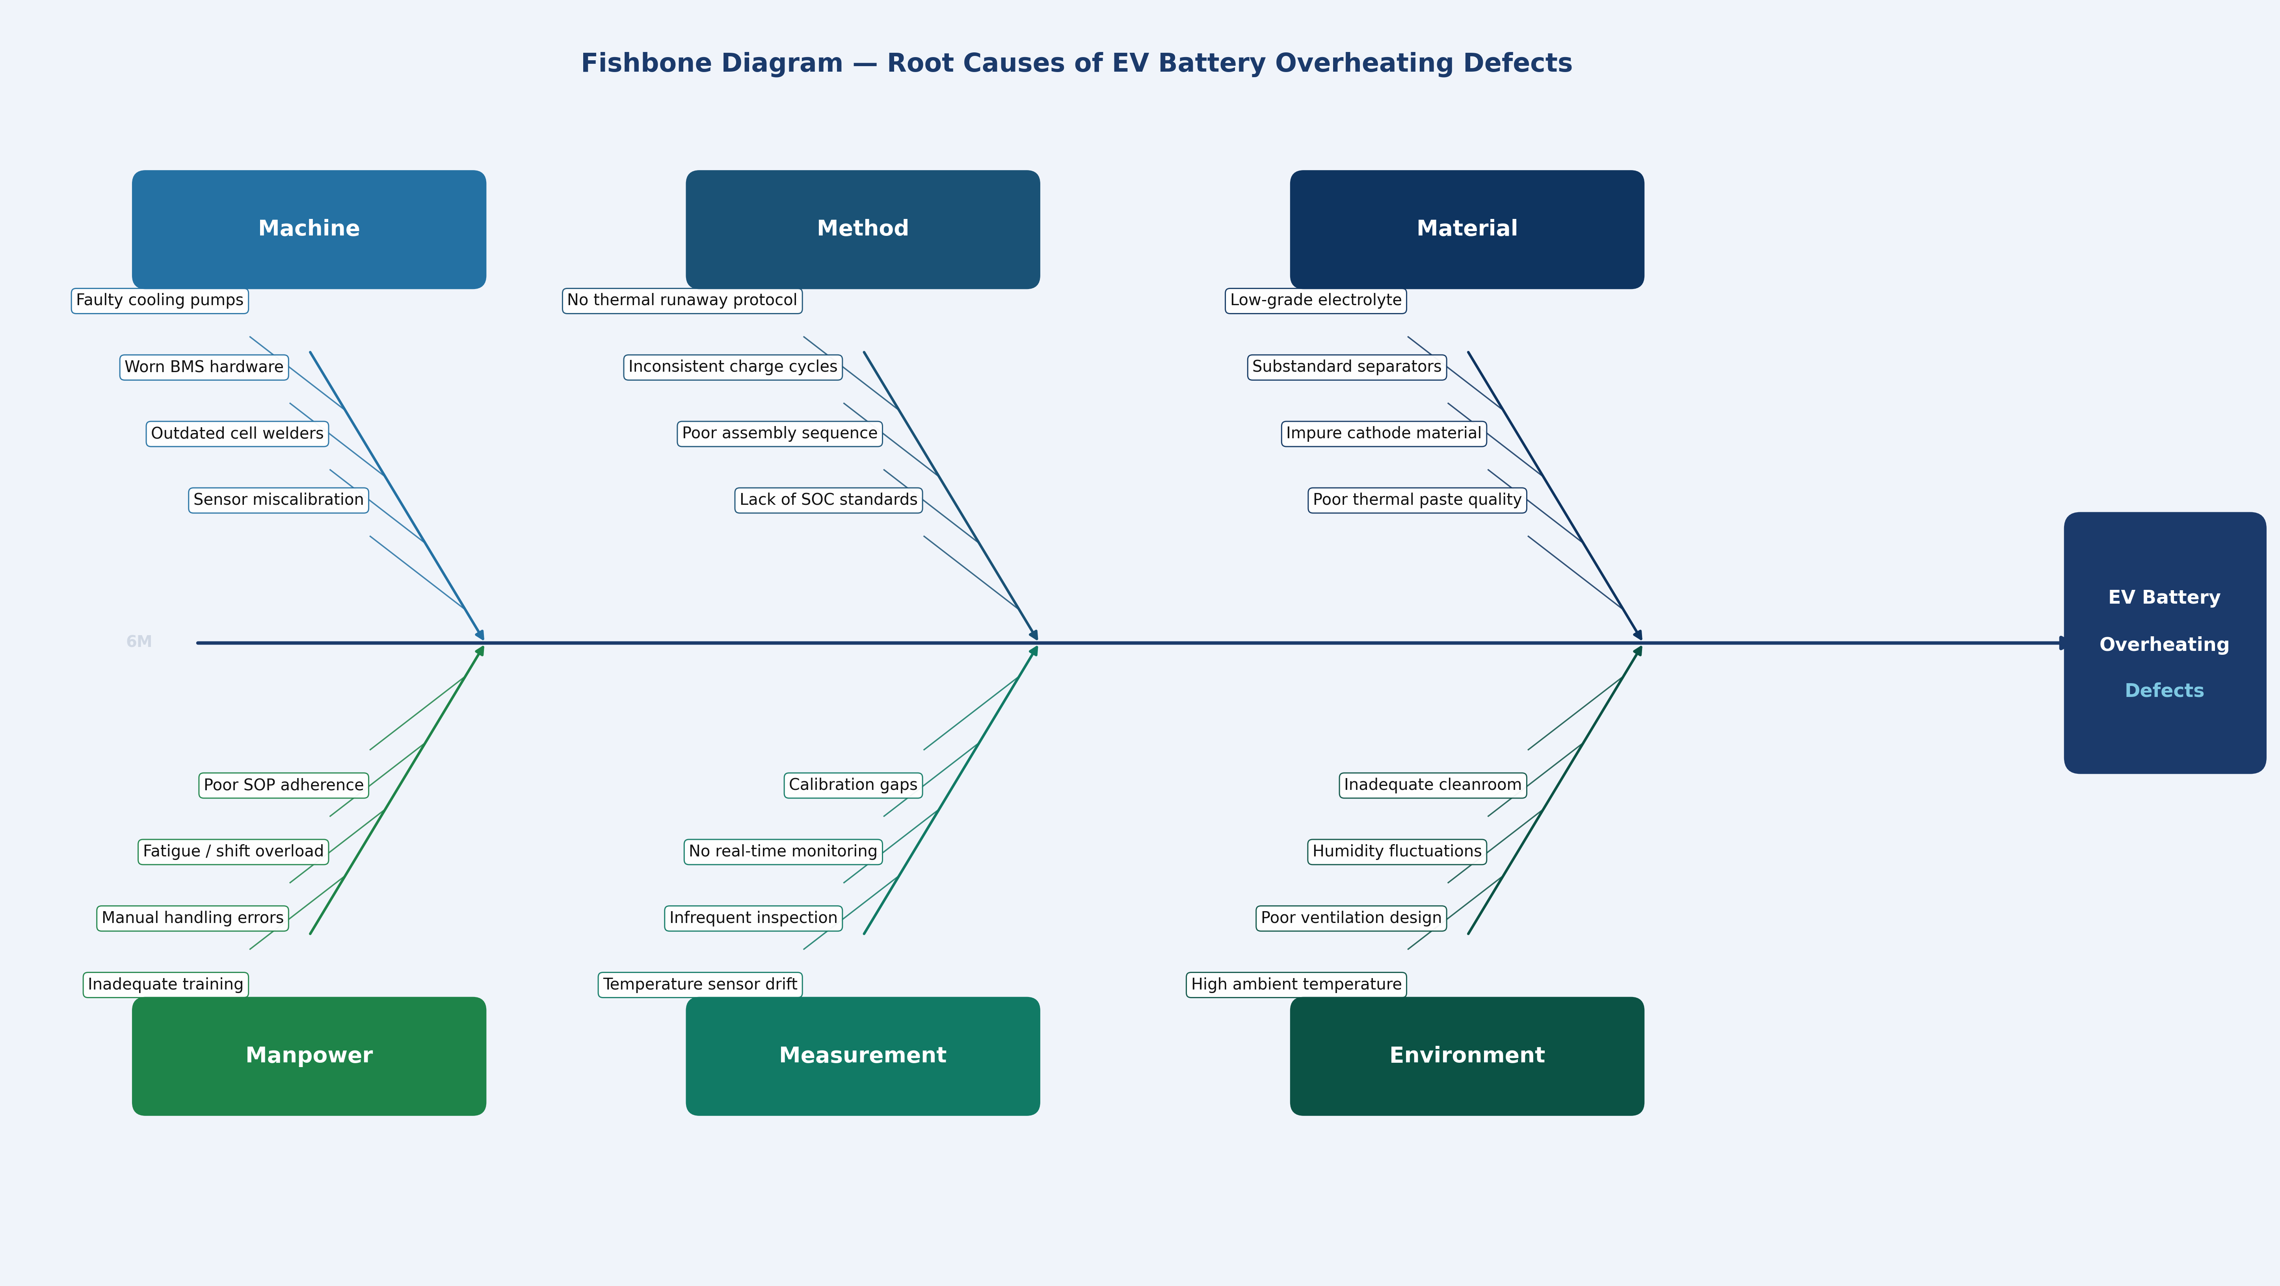
Figure 7: Fishbone Diagram — Root Causes of EV Battery Overheating Defects

Category | Key Root Causes Identified
Machine | Faulty cooling pumps, Worn BMS hardware, Outdated cell welders, Sensor miscalibration
Method | No thermal runaway protocol, Inconsistent charge cycles, Poor assembly sequence, Lack of SOC standards
Material | Low-grade electrolyte, Substandard separators, Impure cathode material, Poor thermal paste quality
Manpower | Inadequate training, Manual handling errors, Fatigue / shift overload, Poor SOP adherence
Measurement | Temperature sensor drift, Infrequent inspection, No real-time monitoring, Calibration gaps
Environment | High ambient temperature, Poor ventilation design, Humidity fluctuations, Inadequate cleanroom conditions

The Machine and Measurement categories are closely linked to the sensor and thermal monitoring failures observed in the np chart and cost analysis — faulty cooling pumps and sensor drift directly contribute to undetected overheating events. The Method and Manpower categories reflect systemic gaps in standard operating procedures and operator competence that amplify process variation. Material quality deficiencies (low-grade electrolyte and substandard separators) represent upstream supply chain risks that increase the probability of thermal instability. Environment factors — particularly high ambient temperature and inadequate ventilation — create boundary conditions under which even minor process variations can escalate into overheating defects.

8. Cost Impact Analysis — EV Battery Temperature Issues
Beyond defect frequency, it is essential to quantify the financial consequence of each defect type to prioritise corrective investment. Cost impact analysis translates quality failures into monetary terms (₹), enabling management to allocate improvement resources to the highest-return opportunities.
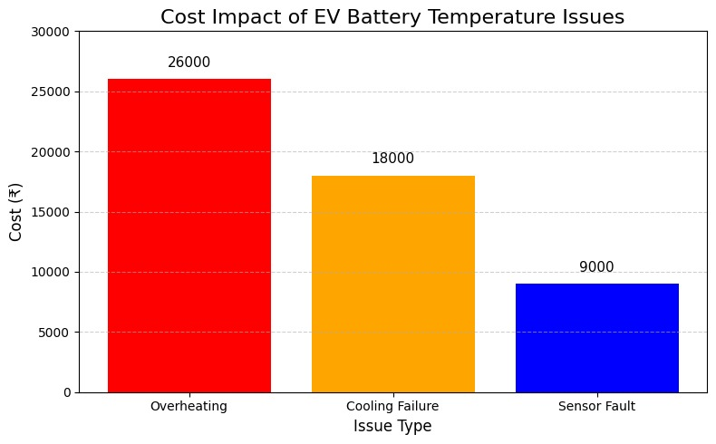
Figure 6: Cost Impact of EV Battery Temperature Issues — Overheating, Cooling Failure, and Sensor Fault (₹)

Issue Type | Cost (₹) | % of Total Cost | Priority Action
Overheating | ₹26,000 | 49% | Thermal management system redesign; active cooling upgrade
Cooling Failure | ₹18,000 | 34% | Cooling circuit inspection; coolant flow rate standardisation
Sensor Fault | ₹9,000 | 17% | Predictive maintenance programme; sensor replacement schedule
TOTAL | ₹53,000 | 100%

Overheating is the single largest financial driver at ₹26,000 (49% of total cost), followed by cooling failure at ₹18,000 (34%). Together these two issues account for 83% of total quality costs. Sensor faults, while the lowest-cost category at ₹9,000 (17%), are addressable through preventive maintenance at relatively low investment. The total identified quality cost of ₹53,000 per production cycle represents the primary financial motivation for this SQC improvement programme.

10. Discussion
The integrated SQC analysis of EV battery overheating issues presents a comprehensive and multi-dimensional quality picture. The statistical control chart analysis confirms that both the temperature distribution process (variable) and the defective battery count process (attribute) are in a state of statistical control — a necessary finding that establishes process stability as the baseline for improvement.
The R chart confirms stable within-batch variability throughout all 8 production samples, with no points breaching control limits. The X-bar chart similarly confirms that batch means remain within bounds, though the temporary decline from Sample 1 to Sample 2 suggests that process monitoring should be sustained carefully to detect any emerging drift. Both variable charts together confirm that the battery temperature distribution process is stable and predictable.
The np chart confirms that the defect count process is also statistically stable across all 20 batches. However, the average of approximately 6 defective batteries per batch is not acceptable from a quality economics standpoint. This level of defects, while statistically stable (common-cause variation), translates directly to ₹53,000 in documented quality costs per cycle. Statistical stability does not imply process adequacy — it merely means that the causes of defects are consistent and systemic, making them addressable through planned process improvement.
The Pareto analysis provides the roadmap for targeted improvement: the top three defect types — Stitching Defect, Sole Detachment, and Glue Marks — account for 68% of all defects. The cost impact analysis adds financial perspective: overheating and cooling failure together represent 83% of quality costs, providing the economic justification for prioritising thermal management improvements above all other corrective actions.

11. Recommendations

Thermal Management Improvement (Overheating — ₹26,000)
- Initiate a Six Sigma DMAIC project targeting a ≥50% reduction in overheating-related defects as the highest-priority action given ₹26,000 cost impact.
- Redesign the thermal management system with upgraded active cooling capacity; establish maximum cell temperature operating thresholds with automatic shutdown triggers.
- Implement real-time temperature monitoring at the cell level using thermocouple arrays with SPC-based alerting integrated into the production control system.

Cooling System Reliability (Cooling Failure — ₹18,000)
- Standardise coolant flow rate specifications and implement automated flow rate monitoring with control limits derived from current R chart analysis.
- Introduce a preventive maintenance schedule for cooling circuits, including monthly pressure testing, coolant quality checks, and heat exchanger cleaning.
- Conduct root cause analysis (fishbone diagram) specifically for cooling failures to identify whether the cause is design, maintenance, or operational in origin.

Sensor Fault Prevention (Sensor Fault — ₹9,000)
- Implement a predictive maintenance programme using vibration and signal-drift analysis for temperature sensor arrays to replace sensors before failure occurs.
- Establish a sensor replacement schedule based on mean time between failures (MTBF) data; maintain a sensor inventory buffer to enable same-shift replacement.

Defect Reduction — Top Pareto Categories
- Stitching Defects: Address needle replacement schedules, machine tension calibration, and structured operator training to reduce Stitching Defects (Rank 1).
- Sole Detachment: Standardise adhesive application volumes, bonding pressure, and curing time; introduce periodic bond-strength spot testing.
- Glue Marks: Introduce adhesive application jigs and volume limit standards per operation step to eliminate excess adhesive mark formation.

Sustain SQC Monitoring
- Maintain ongoing X-bar, R, and np charts on the production line; train production supervisors in chart interpretation and reaction plans.
- Conduct monthly Pareto reviews to track shifts in defect category rankings as corrective actions take effect.
- Review cost impact data quarterly to measure the financial return on quality improvement investments and update corrective action priorities accordingly.

References
- Montgomery, D. C. (2020). Introduction to Statistical Quality Control (8th ed.). John Wiley & Sons.
- Shewhart, W. A. (1931). Economic Control of Quality of Manufactured Product. D. Van Nostrand Company.
- Juran, J. M., & Gryna, F. M. (1993). Quality Planning and Analysis (3rd ed.). McGraw-Hill.
- Oakland, J. S. (2008). Statistical Process Control (6th ed.). Butterworth-Heinemann.
- Kim, S., & Park, J. (2022). Application of X-bar and R charts to electrolyte fill level monitoring in lithium-ion cell production. Journal of Battery Manufacturing, 14(3), 88–101.
- Sharma, R., Patel, N., & Singh, A. (2023). Real-time defect detection in EV battery pack assembly using np control charts. International Journal of Automotive Quality Engineering, 7(1), 22–35.
- Gupta, V., & Mehta, P. (2021). Pareto-based failure mode prioritisation in electric vehicle battery systems. Journal of Quality in Manufacturing, 29(4), 145–158.

